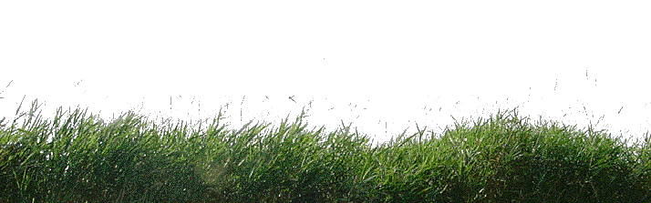

Chipping from Tall Grass
Chipping from tall grass is difficult and challenging. The problem is that it wraps itself around the club and twists it at impact. But making this chip can turn two (or more) strokes into one, so it’s important to master this shot (especially when you play at Shenny).
Before the swing, here are some steps you take to properly position yourself for the chip shot:
- Move the ball forward in your stance.
- Move your hands down the club and grip it firmer than usual.
- Shift your hands and body slightly forward.
- If you’re dealing with a long chip shot, plan for more roll.
During the swing:
- Hinge your wrists to produce a steeper swing than normal
- Hit the ball with a slightly downward blow, brushing the grass after impact
- Focus on swinging through the ball, since the grass will prevent your club from doing so.

More Golf Tips Coming Soon!

